NOTICE OF COMPLETE APPLICATION AND PUBLIC MEETING

TO INFORM THE PUBLIC OF AN OFFICIAL PLAN AND ZONING BY-LAW AMENDMENT

TAKE NOTICE that the Council for The Corporation of the Municipality of Powassan has received a complete application under Sections 22 and 34 of the Planning Act, R.S.O. 1990, c.P. 13 as amended, to inform the public of a proposed Official Plan Amendment and Zoning By-law Amendment.

The public meeting is being held for the application described below to enable interested members of the public to understand and comment on a proposed Official Plan Amendment and Zoning By-law Amendment.

DATE AND LOCATION OF PUBLIC MEETING

File #: 2023-02
Date: Tuesday, October 3, 2023
Time: 6:30 pm
Location: Municipality of Powassan – In the Fire Hall (behind 250 Clark)

DETAILS OF THE ZONING BY-LAW AMENDMENT

The purpose and effect of the proposed Official Plan Amendment is to amend the ‘Rural Area’ designation of the Powassan Official Plan to permit the development of a four-plex (four attached residential dwelling units under one roof with separate entrances) on the subject property. The Rural Area designation policies only permit the development of low-density residential uses.

The purpose and effect of the proposed Zoning By-Law Amendment is to amend the Restricted Area Zoning (By-Law No. 2003-38), as amended, for the lands described as Part Lot 15, Concession 14 RP 42R13092 (Civic Address: 137 Main Street), in the Municipality of Powassan. The amendment will permit a ‘four-plex” as a permitted us in the Rural (RU) zone.

The applications, if approved, would permit the development of a “four-plex” (four attached units under one roof) residential dwelling on the subject property and would rezone the subject property from Rural (RU) to Rural – Special Exemption (RU - Special) to permit a “four-plex” use.

ADDITIONAL INFORMATION AND MAP OF LAND SUBJECT TO THE APPLICATION

A key map showing the land to which the proposed amendments apply is provided with this notice. The purpose of this meeting is to ensure that sufficient information is made available to enable the public to generally understand the applicant’s proposed Official Plan Amendment and Zoning By-law Amendment. Any person who participates in the meeting shall be afforded an opportunity to make representations in respect of the application. Additional information is available for review at the Municipal Office.

If a person or public body does not make written submissions to the Municipality of Powassan before the proposed By-law is passed, the person or public body is not entitled to appeal the decision of the Municipality of Powassan to the Ontario Land Tribunal.

If a person or public body does not make written submissions to the Municipality of Powassan before the proposed By-law is passed, the person or public body may not be added as a party to the hearing of an appeal before the Ontario Land Tribunal unless, in the opinion of the Tribunal, there are reasonable grounds to do so.

If you wish to be notified of the decision of the Council for the Corporation of the Municipality of Powassan in respect to the proposed Zoning By-law Amendment, you must submit a written request (with forwarding addresses) to the Clerk of the Municipality of Powassan at P.O. Box 250, 250 Clark Street, Powassan, Ontario, P0H 1Z0.

Additional information regarding the proposed amendment is available to the public for inspection at the Municipality of Powassan Municipal Office located at 250 Clark Street on Monday to Friday, between the hours of 8:30 a.m. and 4:30 p.m. please call (705) 724-2813.

Mailing Date of this Notice: September 1, 2023

Kimberly Bester, Deputy-Clerk
Municipality of Powassan
kbester@powassan.net

Location Map

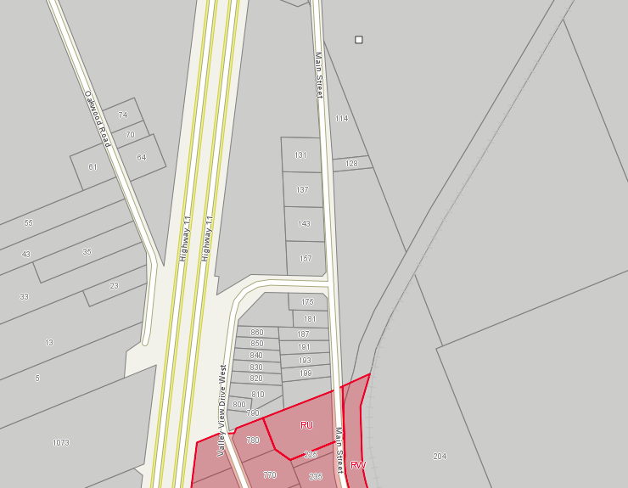

N
Subject Property
137 Main Street

